Assignment 3c

**Query 1**

Shows Data of a worker and its warehouse, the worker works in.

**Query 2**

Shows Data about each warehouse. It specifically shows which printers are inside of each warehouse and shows also data about the printers. Additionally, we get all plans a printer is associated with.

**Query 3**

For every artist we get the plans he/she is associated with and, we get for each of these plans the one worker, who is responsible for this plan.

**Query 3**

This query shows specific info about a worker. We see all the shopping items the worker created (that he/she wants to buy) and all the plans the worker is responsible for.

For every query we limit the output to 100, so that we don’t get to much data back and also the queries are faster. If all data is needed, the (limit 100) clause needs to be removed from each query.

# Query 1

SQL

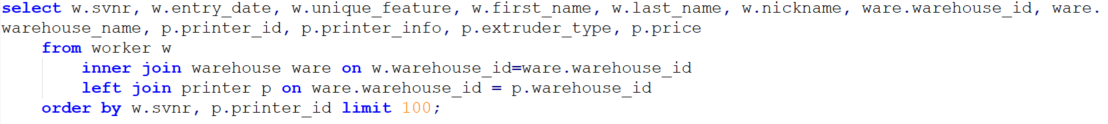

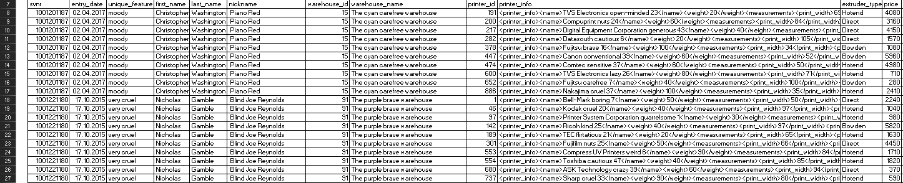

SQLXML

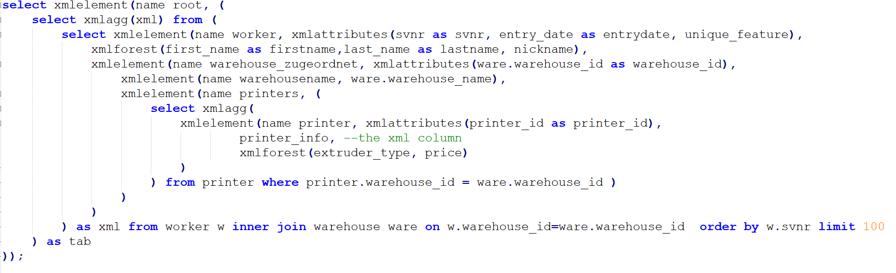

<worker svnr="1001221180" entrydate="2015-10-17" unique_feature="very cruel">

<firstname>Nicholas</firstname>

<lastname>Gamble</lastname>

<nickname> Blind Joe Reynolds</nickname>

<warehouse_zugeordnet warehouse_id="91">

<warehousename>The purple brave warehouse</warehousename>

<printers>

<printer printer_id="680">

<printer_info>

<name>ASK Technology crazy 39</name>

<weight>60</weight>

<measurements>

<print_width>94</print_width>

<print_depth>37</print_depth>

<print_height>22</print_height>

</measurements>

</printer_info>

<extruder_type>Direct</extruder_type>

<price>370</price>

</printer>

….

<printer printer_id="737">

<printer_info>

<name>Sharp cruel 33</name>

<weight>90</weight>

<measurements>

<print_width>80</print_width>

<print_depth>104</print_depth>

<print_height>26</print_height>

</measurements>

</printer_info>

<extruder_type>Hotend</extruder_type>

<price>590</price>

</printer>

</printers>

</warehouse_zugeordnet>

</worker>

</root>

# Query 2

SQL

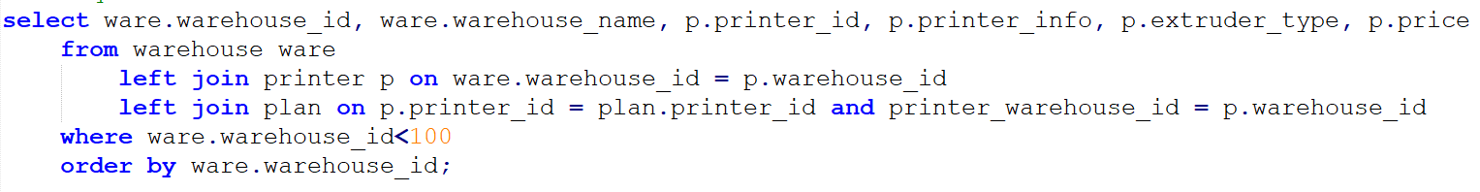

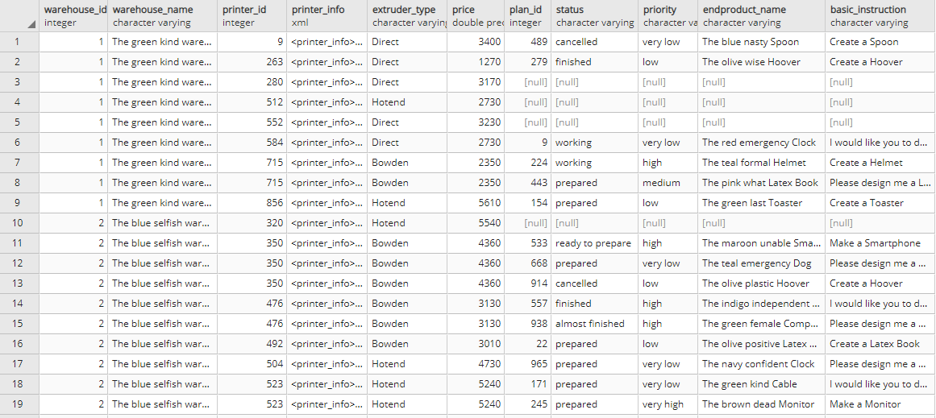

XMLSQL

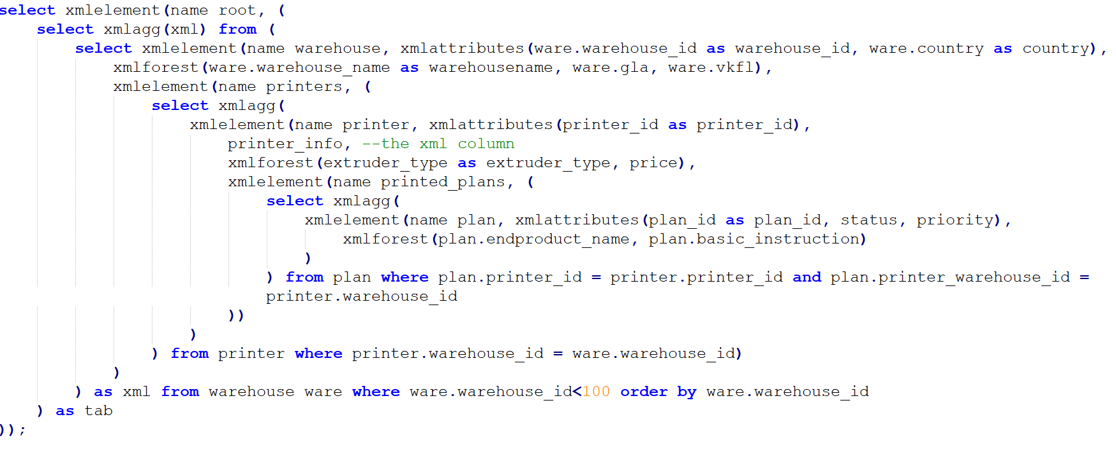

<root>

<warehouse warehouse_id="1" country="Austria">

<warehousename>The green kind warehouse</warehousename>

<gla>3600</gla>

<printers>

<printer printer_id="715">

<printer_info>

<name>UBIX Corp. hard-working 16</name>

<weight>80</weight>

<measurements>

<print_width>84</print_width>

<print_depth>56</print_depth>

<print_height>40</print_height>

</measurements>

</printer_info>

<extruder_type>Bowden</extruder_type>

<price>2350</price>

<printed_plans>

<plan plan_id="224" status="working" priority="high">

<endproduct_name>The teal formal Helmet</endproduct_name>

<basic_instruction>Create a Helmet</basic_instruction>

</plan>

<plan plan_id="443" status="prepared" priority="medium">

<endproduct_name>The pink what Latex Book</endproduct_name>

<basic_instruction>Please design me a Latex Book</basic_instruction>

</plan>

</printed_plans>

</printer>

….

<printer printer_id="856">

<printer_info>

<name>Brother flirtatious 3</name>

<weight>100</weight>

<measurements>

<print_width>35</print_width>

<print_depth>70</print_depth>

<print_height>20</print_height>

</measurements>

</printer_info>

<extruder_type>Hotend</extruder_type>

<price>5610</price>

<printed_plans>

<plan plan_id="154" status="prepared" priority="low">

<endproduct_name>The green last Toaster</endproduct_name>

<basic_instruction>Create a Toaster</basic_instruction>

</plan>

</printed_plans>

</printer>

</printers>

</warehouse>

</root>

# Query 3

SQL

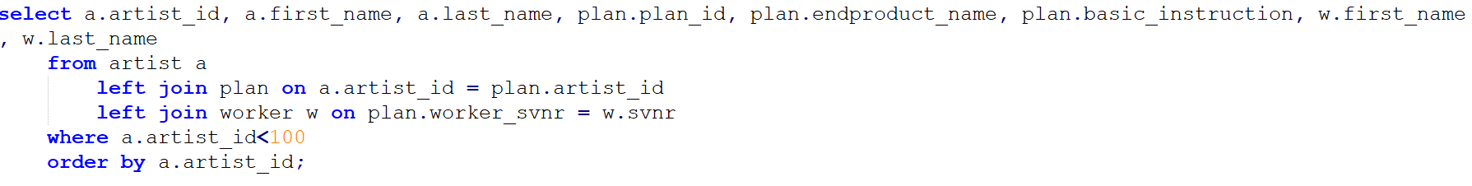

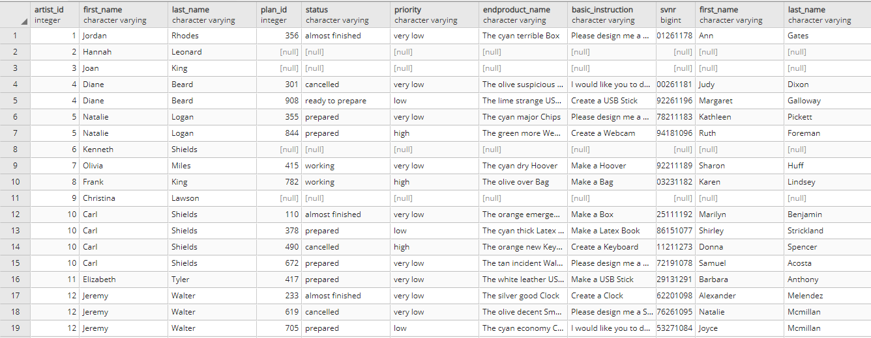

XMLSQL

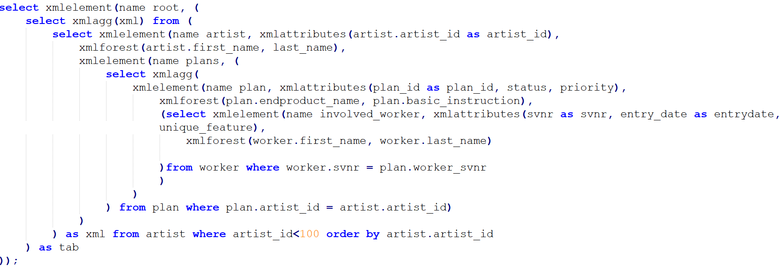

<root>

<artist artist_id="1">

<first_name>Jordan</first_name>

<last_name>Rhodes</last_name>

<plans>

<plan plan_id="356" status="almost finished" priority="very low">

<endproduct_name>The cyan terrible Box</endproduct_name>

<basic_instruction>Please design me a Box</basic_instruction>

<involved_worker svnr="5501261178" entrydate="2013-08-18" unique_feature="self-confident">

<first_name>Ann</first_name>

<last_name>Gates</last_name>

</involved_worker>

</plan>

</plans>

</artist>

<artist artist_id="2">

<first_name>Hannah</first_name>

<last_name>Leonard</last_name>

<plans/>

</artist>

<artist artist_id="3">

<first_name>Joan</first_name>

<last_name>King</last_name>

<plans/>

</artist>

</root>

# Query 4

SQL

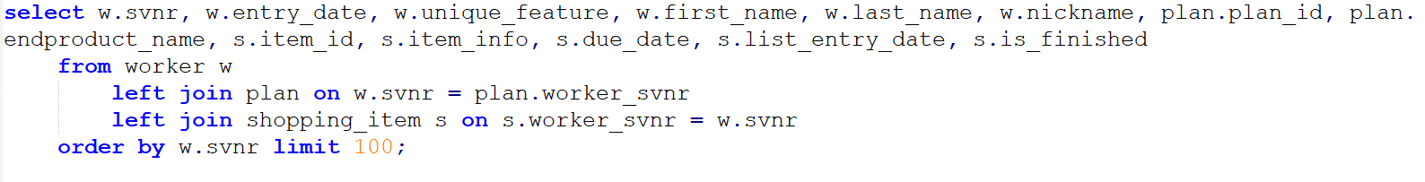

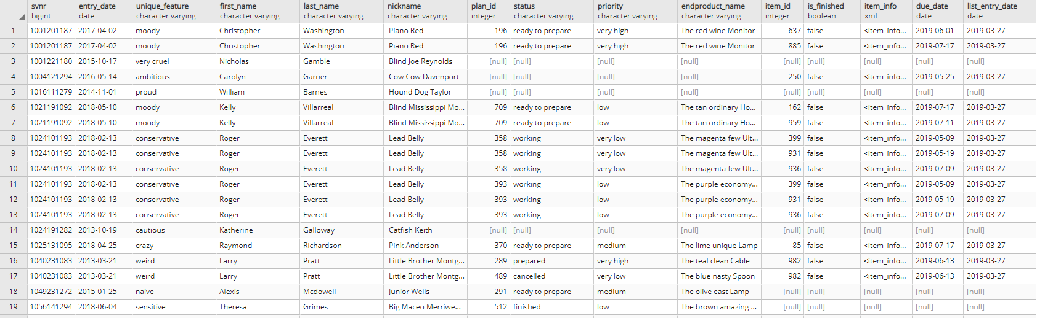

XMLSQL

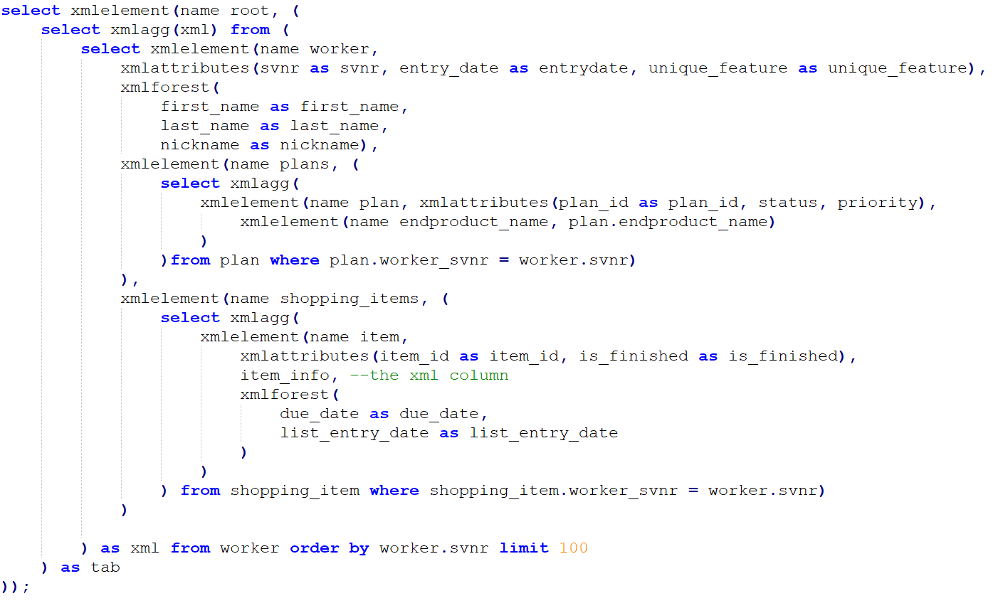

<root>

<worker svnr="1001201187" entrydate="2017-04-02" unique_feature="moody">

<first_name>Christopher</first_name>

<last_name>Washington</last_name>

<nickname> Piano Red</nickname>

<plans>

<plan plan_id="196" status="ready to prepare" priority="very high">

<endproduct_name>The red wine Monitor</endproduct_name>

</plan>

</plans>

<shopping_items>

<item item_id="637" is_finished="false">

<item_info>

<buying_info>

<seller_suggestion>Etsy</seller_suggestion>

<name>silver Wallet</name>

</buying_info>

<additional_info>Whenever there is a problem... SOLVE IT!</additional_info>

</item_info>

<due_date>2019-06-01</due_date>

<list_entry_date>2019-03-27</list_entry_date>

</item>

<item item_id="885" is_finished="false">

<item_info>

<buying_info>

<seller_suggestion>Kohls</seller_suggestion>

<name>orange CD Elton John</name>

</buying_info>

<additional_info>It should be fancy.</additional_info>

</item_info>

<due_date>2019-07-17</due_date>

<list_entry_date>2019-03-27</list_entry_date>

</item>

</shopping_items>

</worker>

</root>